Experiment: Git Configuration and Source Code Repository

Software Installed
- Git Bash
- Notepad++

Git Configuration

Configure Username
git config --global user.name "Aishwarya"

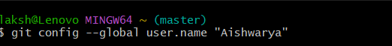

Configure Email
git config --global user.email "lakshmiaiswaryat@gmail.com"

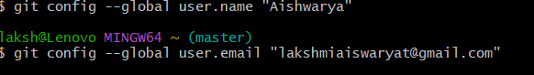

Verify Configuration
git config --global --list

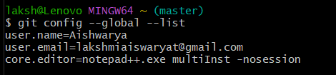

Integrate Notepad++ as Default Editor
Verify Notepad++
notepad++


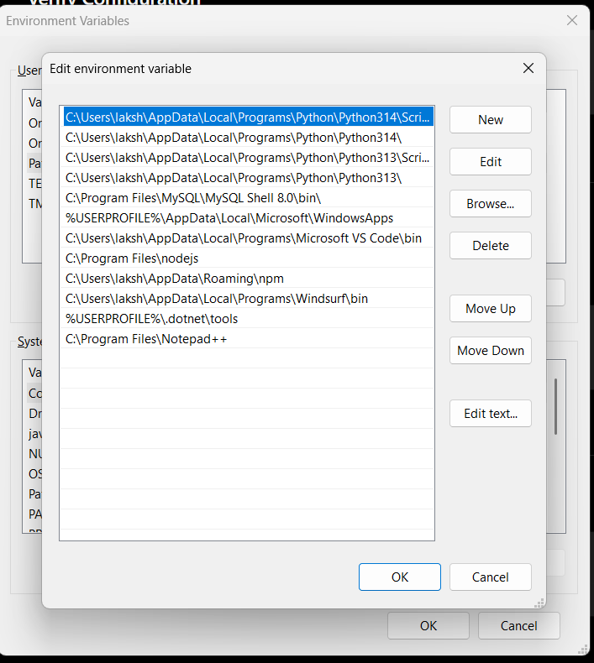
Configure Default Editor
git config --global core.editor "notepad++.exe -multiInst -nosession"

Verify Default Editor
git config --global -e

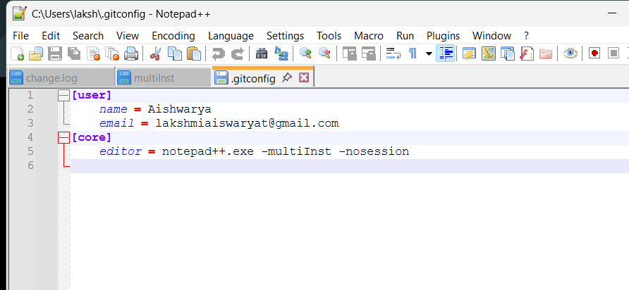

Add a File to Source Code Repository
Clone Repository
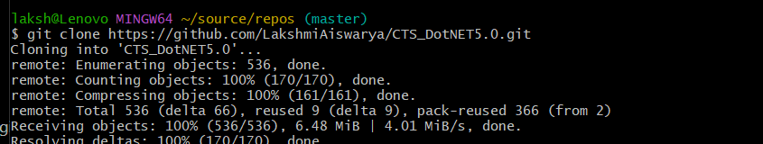
git clone https://github.com/LakshmiAiswarya/CTS_DotNET5.0.git
Navigate to Repository
cd /c/Users/laksh/source/repos/CTS_DotNET5.0
cd "Deep Skilling"
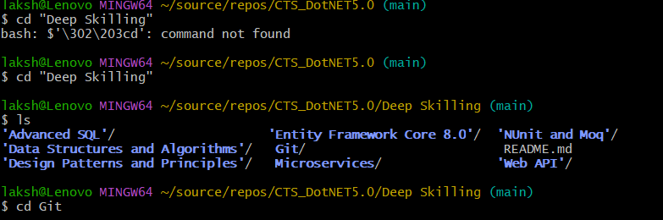
cd Git

Create File
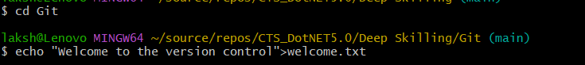
echo "Welcome to the version control" > welcome.txt
Verify File
ls
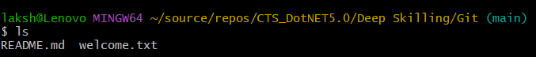
Display File Content
cat welcome.txt

Check Status
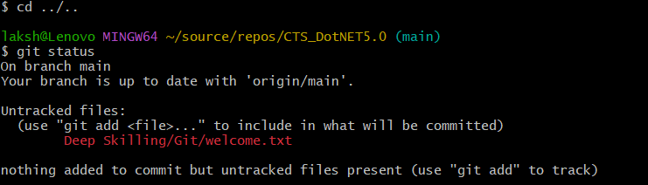
git status

Add File
git add .
Commit File
git commit -m "Added welcome.txt"
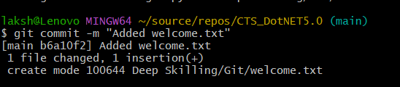

Push to GitHub
git push origin main
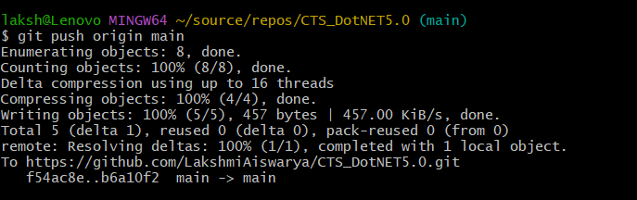

Check Status
git status
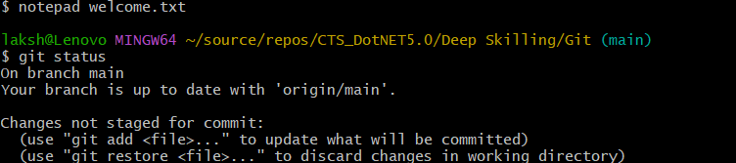
Result
Git was configured successfully, Notepad++ was set as the default editor, and the welcome.txt file was created, committed, and pushed to the GitHub repository successfully.

